Article

Human serum albumin nanoparticles: synthesis, optimization and immobilization with antituberculosis drugs

Aldana Galiyeva*, Arailym Daribay, Tolkyn Zhumagaliyeva, Lyazzat Zhaparova, Daniyar Sadyrbekov, Yerkeblan Tazhbayev*

|  |
| --- |
| **Citation:** To be added by editorial staff during production.  Academic Editor: Firstname Lastname  Received: date  Revised: date  Accepted: date  Published: date    **Copyright:** © 2023 by the authors. Submitted for possible open access publication under the terms and conditions of the Creative Commons Attribution (CC BY) license (https://creativecommons.org/licenses/by/4.0/). |

1 Kazakhstan, Karaganda city, Institute of Chemical Problems, Karagandy University of the name of academician E.A. Buketov

**\*** Correspondence: aldana_karaganda@mail.ru; tazhbayev@mail.ru;

**Abstract:** The aim of this study was to create nanoparticles of human serum albumin immobilized with anti-TB drugs (rifampicin, isoniazid) using the desolvation method. Central Composite Design (CCD) was applied to study the effect of albumin, urea, L-cysteine, rifampicin and isoniazid concentration on particle size, polydispersity and loading degree of drugs. The optimized nanoparticles were spherical in shape with an average particle size of 216.7±3.7 nm and polydispersity of 0.286±4.9. The loading degree of rifampicin and isoniazid in the optimized nanoparticles were 44% and 27% respectively. The obtained nanoparticles were examined by thermogravimetric analysis (TGA) and differential scanning calorimetry (DSC), the results showed the absence of drug-polymer interaction. The drug release from the polymer matrix was studied using dialysis membranes.

**Keywords:** nanoparticles; albumin; rifampicin; isoniazid; antituberculosis drugs; desolvation

1. Introduction

Tuberculosis (TB) is one of the world's leading infectious killers. The COVID-19 pandemic continues to have a devastating impact on access to TB diagnosis and treatment. Progress to 2019 has slowed, halted or reversed, and global TB targets are off track [1]. TB incidence rates (new cases per 100 000 population per year) increased by 3.6% between 2020 and 2021 [1]. The burden of drug-resistant TB (DR-TB) is also estimated to increase, with 450 000 (95% UI: 399 000-501 000) new cases of rifampicin-resistant TB (RR-TB) in 2020-2021 [1]. New approaches for the treatment of TB, including for multidrug-resistant TB, therefore need to be developed.

Isoniazid (INH) and rifampicin (RIF) are the two main anti-TB drugs widely used in the treatment of tuberculosis [2-4]. The combination of isoniazid and rifampicin supplements the action of each of the separately administered drugs and ensures more effective destruction of the bacteria. Moreover, the use of combination therapy reduces the likelihood of the bacteria developing resistance to the drugs [5-6]. However, they can also cause some side-effects, such as hepatotoxicity, neurotoxicity, hypersensitivity and vitamin B6 deficiency [7-9]. It can also cause allergic reactions such as skin rashes, itching, urticaria, and sometimes more severe reactions such as angioedema, anaphylaxis and other allergic manifestations [10].

Reducing the side-effects and resistance of rifampicin and isoniazid is a challenge, but several approaches exist, one of which is the use of polymer composites for drug transport [11-14]. The use of nanoparticles (NPs) may allow drugs to be delivered directly to the site of infection and reduce their toxicity to the body.

Biodegradable polymers such as polylactide, copolymers of polylactic and glycolic acids, human and bovine albumin, and polyethylene glycol are used for nanoparticle synthesis [15-17]. The use of albumin-based nanoparticles for the transport of TB drugs is promising, as bioavailability is improved, stability is increased and toxicity is reduced, transport specificity is increased, and resistance to drug resistance is improved [18-21].

Albumin-based nanoparticles loaded with isoniazid and rifampicin represent a promising approach for the treatment of tuberculosis. However, determining the optimum conditions for the production of such nanoparticles is a challenging task requiring careful research and optimization of various process parameters. In this context, the central composite design (CCD) method is an effective tool to optimize and improve the process of producing albumin-based nanoparticles loaded with isoniazid and rifampicin in order to improve their effectiveness and stability.

Thus, we were interested to use biodegradable polymeric nanoparticles immobilized with isoniazid and rifampicin with sustained action, targeted delivery, with high efficacy and reduced toxic side effects, and to increase the effectiveness of tuberculosis treatment. Rifampicin and isoniazid loaded human serum albumin (HSA-INH-RIF) NPs were optimized by CCD and the effects of 5 factors were investigated: concentrations of HSA, urea, L-cysteine, rifampicin and isoniazid.

2. Materials and Methods

*2.1. Materials:*

Human serum albumin (lyophilized powder, 98%), rifampicin and isoniazid with in-dicated purity over 99%, and L-cysteine (98.5%) were purchased from Sigma Aldrich (Saint Louis, MO, USA Germany). Absolute ethanol was purchased from DosFarm (Almaty, Kazakhstan). Urea (99.5%) was purchased from HimPribor-SPb (Saint Petersburg, Russia).

*2.2. Production of human serum albumin nanoparticles loaded with isoniazid and rifampicin by desolvation*

Nanoparticles of human serum albumin were prepared by desolvation [18]. According to this technique, a given amount of serum albumin was dissolved in distilled water while stirring at 200 rpm, avoiding clumping and foaming, at room temperature for 10 min. The concentration of these prepared protein solutions was 10 - 100 mg/mL. Then a given amount of aqueous urea solution (at a concentration of 4 - 6 mol/L) was added and treated with ultrasound (Launch Tech, Shenzhen, China) for 3 min. Ethanol was then added to each protein solution at a constant rate (1 mL/min), resulting in a turbid dispersion of albumin nanoparticles. An aqueous solution of L-cysteine was then added, in which the concentration of the amino acid was 0.1 - 2.5 mg/mL. Pre-prepared solution of isoniazid and rifampicin was added to the obtained HSA nanoparticles so that the drug concentration in the system was 2 - 8 mg/mL and stirred (stirring speed was 300 rpm) for 2 h. The nanoparticle suspension was then purified by three cycles of centrifugation at 14 000 rpm (MiniSpin, Eppendorf, Hamburg, Germany) for 15 min to remove unabsorbed isoniazid and rifampicin.

*2.3. Determination of particle size, polydispersity and ζ-potential*

Particle size and polydispersity of the nanoparticles were determined by photon correlation spectroscopy on a Zetasizer Nano S90 from Malvern (Malvern Instruments Ltd., Malvern, UK). For all measurements, each sample was diluted to the appropriate concentration with distilled water. Each dimensional assay lasted 120 seconds and was performed at 25°C with a 90° angle determination. Ζ-potential was measured with a ζ-potential analyzer (Zetasizer Nano ZS90, Malvern Instruments, Worcestershire, UK) using electrophoretic laser Doppler anemometry. As well as the size, shape and surface morphology of nanoparticles were investigated by scanning electron microscopy (MIRA 3LM TESCAN, Brno, Czech Republic, EU).

*2.4. Determination loading degree of drugs and nanoparticles’ yield*

The amount of drug in the supernatant was determined by high performance liquid chromatography (HPLC) (Shimadzu LC-20 Prominence). The detector instrument was set to a wavelength of 254 nm. Mobile phase water - acetonitrile - formic acid (94:5:1), flow rate 1.5 mL/min. An Agilent 300 Extend (Agilent Technologies, Tokyo, Japan) C-18 column (sorbent grain size 5 μm, 100 Å, 4.6 × 150 mm) was used. The operating temperature of the column was maintained at 40 °C. The quantification method was internal area normalization. The instrument was set up for an injection volume of 10 μL (loop injection).

The amount of drug encapsulated in polymer nanoparticles was determined by measuring the amount of unencapsulated drug in the aqueous solution recovered after ultracentrifugation and particle washing. The loading degree was calculated as follows:

*2.5. In vitro study of drug release from polymer nanoparticles*

Cumulative drug release from the polymer matrix was determined by dialysis in saline phosphate buffer (pH 7.4) at 37°C. For this purpose, nanoparticles immobilized by the drug were dispersed in phosphate buffer and treated with ultrasound for 10 min. The resulting dispersion was transferred to a dialysis membrane (MWCO 8000D). The membrane, sealed with clamps, was placed in a dialysis beaker with buffer solution, covered with a lid and stirred on a magnetic stirrer at 200 rpm. Dialysate samples were taken periodically. To study the degree of release from the polymer nanoparticles, the amount of drug released was recorded by HPLC and calculated according to the formula:

*2.6. Experimental design of central composite design*

NPs were formulated according to a central composite design (CCD) to investigate the effect of the independent variables, i.e. the concentrations of HSA, urea, cysteine, isoniazid and rifampicin on particle size and loading degrees of isoniazid and rifampicin. The CCD matrix was generated using Design Expert® software (version 13, Stat-Ease, Minneapolis, MN, USA) and to estimate five factors at five levels (Table 1), the design consisted of eleven factorial point batches, ten axial point batches and five replicates at central points.

**Table 1.** Experimental factors for synthesis of HSA-INH-RIF NPs and corresponding levels

|  |  |  |  |  |  |  |
| --- | --- | --- | --- | --- | --- | --- |
| Independent variable | Measuring unit | Variable levels | | | | |
| Star-low  (-1.82) | Low  (-1) | Center  (0) | High  (1) | Star-high  (1.82) |
| A: [HSA] | mg/mL | 10 | 20 | 40 | 80 | 100 |
| B: [Urea] | mol/L | 3 | 4 | 5 | 6 | 7 |
| C: [L-cysteine] | mg/mL | 0.1 | 0.5 | 1.25 | 2 | 2.5 |
| D: [INH] | mg/mL | 2 | 4 | 6 | 8 | 10 |
| E: [Rif] | mg/mL | 2 | 4 | 6 | 8 | 10 |

3. Results

*3.1. Optimization of Nanoparticles Preparation*

The desolvation procedure is a common method to produce protein-based particles [22-24]. Desolvation of HSA with ethanol results in clearly delineated nanoparticles with denatured albumin forming a matrix of spheres [25]. Previous studies have mainly used the glutardialdehyde as a crosslinking agent to prepare albumin-based nanoparticles [26, 27]. We propose a method that eliminates the use of synthetic stabilizer, replacing it with natural agents such as urea and cysteine. For this purpose, we modified a previously developed technique for the anti-tumour drug hydroxyurea [28, 29]. Human serum albumin nanoparticles containing isoniazid were prepared by desolvation, in which urea was used as a denaturing agent, ethanol was used as a desolvating agent, followed by a reduction step with L-cysteine [18]. Immobilization of the drug isoniazid was carried out using the inclusion method (Figure 1).

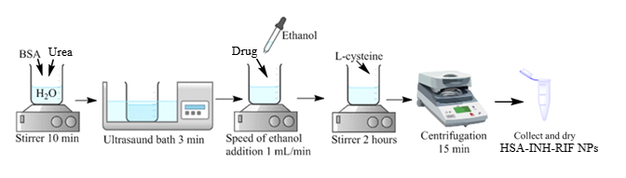

**Figure 1.** Scheme for producing HSA-INH-RIF nanoparticles

The central composite design method (CCD) was used to study the effect of formulation factors (concentrations of HSA, urea, L-cysteine, rifampicin and isoniazid) on the dependent physico-chemical characteristics, particle size and drug loading degree. CCD is an alternative approach as it gives the possibility to investigate a large number of variables at different levels with a limited number of experiments. The variables in Table 1 have been chosen based on our initial experiments. Table 2 presents the results of the effect of the estimated variables on the drug loading degree and average particle size.

**Table 2.** Formulations of HSA-INH-RIF NPs using central composite design and their evaluation parameters.

|  |  |  |  |  |  |  |  |  |  |  |
| --- | --- | --- | --- | --- | --- | --- | --- | --- | --- | --- |
| Formulation code | A: [HSA] (mg/mL) | B: [Urea] (mol/L) | C: [L-cystein] (mg/mL) | D: [INH] (mg/mL) | E:[RIF]  (mg/mL) | Size  (nm) | PDI | Loading degree  of INH (%) | Loading degree  of RIF (%) | NPs yield (%) |
| NP1 | 40 | 5 | 1.25 | 6 | 6 | 221.2±4.4 | 0.108±0.028 | 17 | 17 | 66 |
| NP2 | 80 | 6 | 2 | 4 | 4 | 251.6±7.2 | 0.146±0.003 | 21 | 25 | 21 |
| NP3 | 40 | 5 | 1.25 | 6 | 10 | 231.4±1.8 | 0.135±0.037 | 15 | 7 | 54 |
| NP4 | 40 | 5 | 1.25 | 6 | 6 | 159.6±2.8 | 0.208±0.009 | 6 | 12 | 66 |
| NP5 | 40 | 5 | 1.25 | 6 | 6 | 289.5±2.9 | 0.452±0.039 | 30 | 51 | 34 |
| NP6 | 80 | 4 | 2 | 4 | 8 | 327.3±6.6 | 0.446±0.004 | 20 | 39 | 6 |
| NP7 | 20 | 6 | 0.5 | 8 | 8 | 152.8±6.5 | 0.345±0.048 | 53 | 32 | 33 |
| NP8 | 40 | 3 | 1.25 | 6 | 6 | 191.6±9.7 | 0.198±0.043 | 7 | 13 | 68 |
| NP9 | 40 | 5 | 1.25 | 6 | 6 | 253.1±5.7 | 0.207±0.049 | 22 | 22 | 12 |
| NP10 | 10 | 5 | 1.25 | 6 | 6 | 174.9±2.9 | 0.171±0.039 | 51 | 51 | 27 |
| NP11 | 80 | 6 | 0.5 | 8 | 4 | 351.6±7.3 | 0.145±0.004 | 25 | 78 | 5 |
| NP12 | 20 | 4 | 0.5 | 4 | 4 | 191.4±9.4 | 0.191±0.047 | 26 | 26 | 43 |
| NP13 | 40 | 5 | 2.5 | 6 | 6 | 156.1±8.4 | 0.335±0.016 | 21 | 21 | 53 |
| NP14 | 20 | 6 | 2 | 8 | 4 | 232.1±3.9 | 0.424±0.006 | 18 | 90 | 14 |
| NP15 | 40 | 5 | 1.25 | 10 | 6 | 336.6±9.5 | 0.414±0.075 | 32 | 33 | 69 |
| NP16 | 100 | 5 | 1.25 | 6 | 6 | 136.3±9.7 | 0.189±0.038 | 23 | 24 | 39 |
| NP17 | 80 | 4 | 2 | 8 | 4 | 216.5±5.4 | 0.241±0.025 | 34 | 21 | 51 |
| NP18 | 80 | 4 | 0.5 | 8 | 8 | 134.2±7.7 | 0.259±0.001 | 23 | 25 | 49 |
| NP19 | 20 | 6 | 2 | 4 | 8 | 233.2±5.6 | 0.193±0.005 | 29 | 22 | 7 |
| NP20 | 20 | 4 | 2 | 8 | 8 | 239.6±8.8 | 0.127±0.030 | 19 | 30 | 38 |
| NP21 | 40 | 5 | 0.1 | 6 | 6 | 243.2±5.8 | 0.248±0.019 | 39 | 39 | 15 |
| NP22 | 40 | 5 | 1.25 | 6 | 2 | 215.5±2.4 | 0.443±0.056 | 26 | 23 | 36 |
| NP23 | 80 | 6 | 0.5 | 4 | 8 | 304.7±9.1 | 0.347±0.002 | 42 | 21 | 20 |
| NP24 | 40 | 5 | 1.25 | 2 | 6 | 184.2±9.6 | 0.187±0.016 | 20 | 19 | 26 |
| NP25 | 40 | 7 | 1.25 | 6 | 6 | 204.7±4.1 | 0.214±0.007 | 7 | 7 | 63 |
| NP26 | 40 | 5 | 1.25 | 6 | 6 | 177.5±5.3 | 0.189±0.032 | 8 | 26 | 45 |

The particle size and polydispersity (PDI) of HSA-INH-RIF NPs ranged from 134.2±7.7 to 351.6±7.3 nm, 0.108±0.028 to 0.452±0.039, respectively. The smallest particle size was determined for NP18 formulation (134.2±7.7 nm), at 80 mg/mL albumin, 4 mol/L urea, 0.5 mg/mL cysteine and 8 mg/mL drug concentration.

The loading degree and NPs’ yield are important parameters in the synthesis of polymeric carriers. The drug loading and NPs’ yield ranged from 8 to 90% and 5 to 69%, respectively.

Analysis of variance (ANOVA) was applied to examine the suitability and significance of the mathematical model to estimate the particle size and loading degree (Table 3). The multiple regression data show that the quadratic terms should be retained in the mathematical model to determine the responses.

**Table 3.** ANOVA results for particles size and loading efficiency of drugs

|  |  |  |  |  |  |  |  |
| --- | --- | --- | --- | --- | --- | --- | --- |
| Response | Source | Sum of Squares | Degree of freedom | Mean Square | F-value | p-value |  |
| Size | Model | 8.643×1012 | 21 | 4.116×1011 | 10.52 | 0.0171 | significant |
| Pure Error | 1.564×1011 | 4 | 3.911×1010 |  |  |  |
| Cor Total | 8.800×1012 | 25 |  |  |  |  |
| **Loading degree of INH** | Model | 6.619×108 | 20 | 3.310×107 | 4.70 | 0.0469 | significant |
| Pure Error | 6.019×106 | 4 | 1.505×106 |  |  |  |
| Cor Total | 6.971×108 | 25 |  |  |  |  |
| Loading degree of RIF | Model | 7.385×109 | 2 | 3.692×108 | 4.93 | 0.0426 | significant |
| Pure Error | 2.429×106 | 4 | 6.072×105 |  |  |  |
| Cor Total | 7.759×109 | 25 |  |  |  |  |

The F-value of the model for the mean size, equal to 10.52, means that the model is significant. The probability that such a large F-value could arise due to noise is only 1.71%. A P-value of less than 0.0500 indicates that the model conditions are significant (Table 3).

The F-value of the model for rifampicin loading degree, equal to 4.93, means that the model is significant. The probability that such a high F-value could arise from noise is only 4.26%.

A model F-value for isoniazid loading degree of 4.70 means that the model is significant. The probability that such a large F-value could arise from noise is only 4.69%.

The model developed on the basis of the CCD to estimate the particle size and the degree of loading of each drug, respectively, is as follows:

Size =205.99 + 3.11A + 13.61B+20.56C- 4.45D+ 18.26 E+ 23.23A * B + 15.30A * C+ 49.53A * D-21.70A * E+ 14.87B * C+19.98B * D-52.02 B * E+ 24.58C* D-47.50C* E+26.04D* E+48.78A² -30.56B² + 22.84C² -11.10D² -8.08E²

Loading degree of RIF = 25.02 - 7.69A + 9.36B - 6.02C+ 6.35D+21.40E+17.55A * B +29.43A * C+10.06A * D-0.99A * E+ 18.38B * C-12.74B * D+-25.29B * E+ 3.14C* D- 5.41C* E- 15.53D* E- 1.57A² + 2.68B² - 0.45C² + -6.49D² + 12.07E²

Loading degree of INH = 20.62 - 1.34A + 9.36B + 1.00 C+ 6.35 D+ 3.34E+ 1.83A * B + 6.94A * C+ 4.34A * D+ 7.60A * E+ 5.49B * C- 10.36B * D- 1.35B * E- 2.50C* D+ 10.26C* E- 4.84D* E- 2.23A² + 6.27B² 7.83C² -2.90D² -4.47E²

These equations take into account only those conditions that are statistically significant, as shown by ANOVA. The relationship between the dependent and independent parameters can be represented graphically by means of response surface diagrams for the two variables simultaneously.

The influence of the different factors on the particle size has been evaluated by means of a three-dimensional (3D) response surface diagram shown in Figure 2.

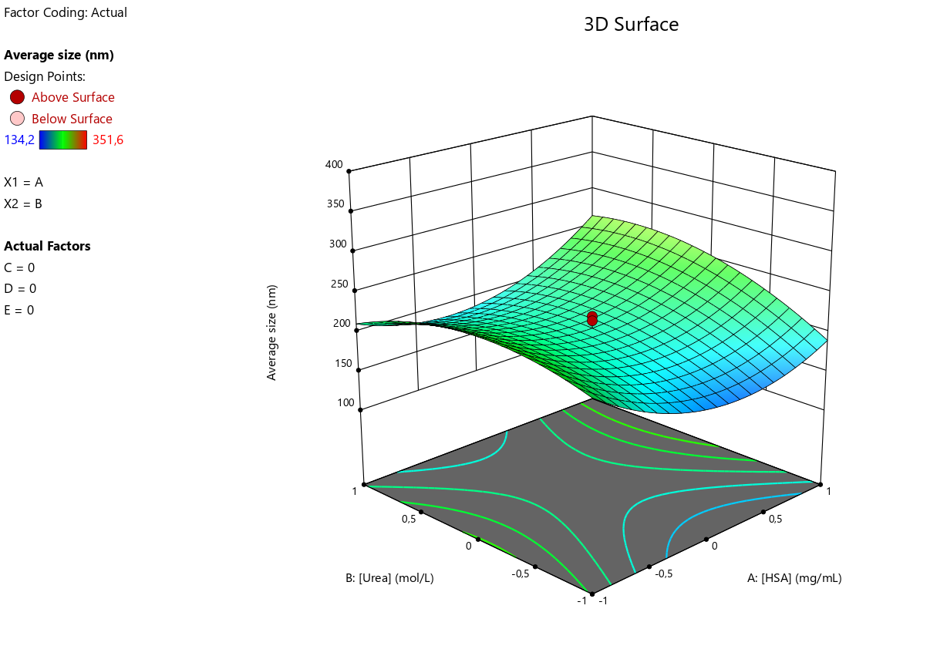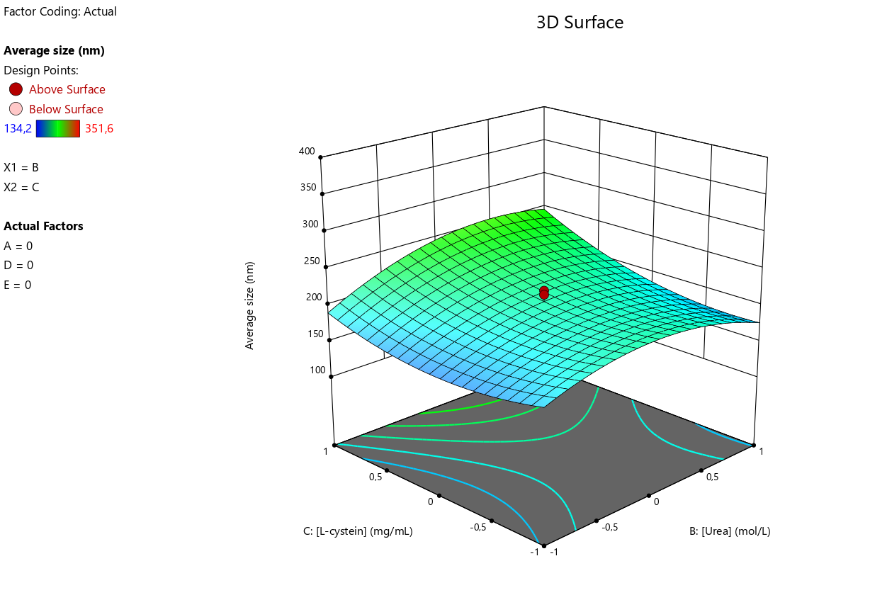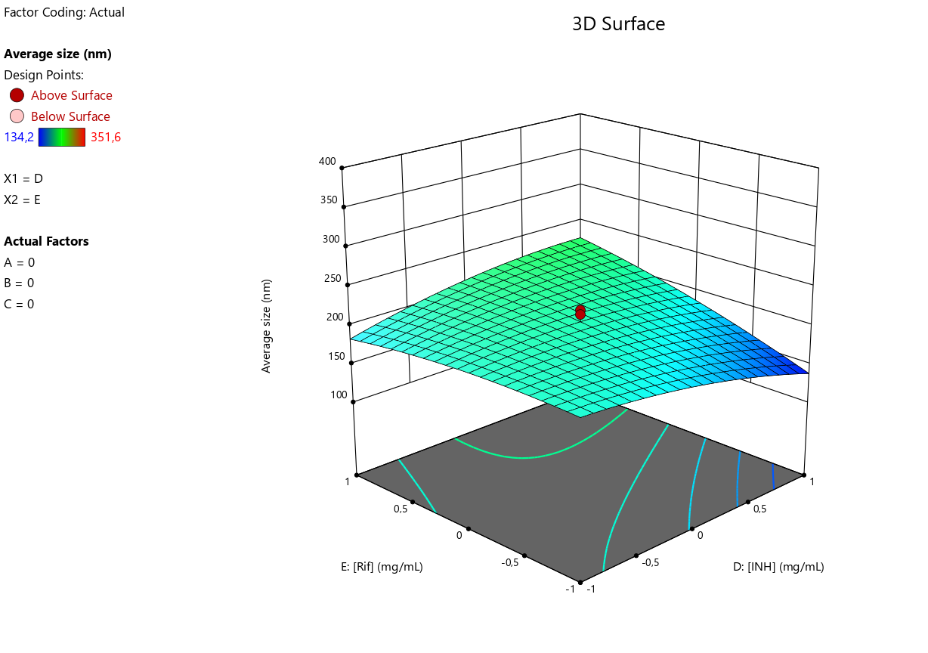

(a) (b) (c)

**Figure 2.** Three-dimensional (3D) response surface plots of the effect of independent factors on average particle size: (a) [HSA] - [Urea]; (b) [Urea] - [L-cysteine]; (c) [INH] - [RIF]

Therefore, the plots were prepared by plotting the response surface (i.e. average NPs size) against the two effective factors, which shows a binary interaction, while the other factors remain unchanged. Figure 2a shows that with increasing concentrations of HSA and urea, the average particle size increases, but at central concentrations of albumin ([HSA]=40 mg/mL) the NP size decreases, while at central concentrations of urea ([Urea]=5 mg/mL) the average size increases. At central concentrations of cysteine ([L-cysteine]=1.25 mg/mL), the smallest NPs size is achieved (Figure 2b). Drug concentrations (Fig. 3c) have a similar effect on the average particle size, with increasing drug concentrations decreasing the average particle size, thus using the highest concentration of isoniazid results in the smallest particle size (at [INH] = 10 mg/mL average particle size 141.6 nm as predicted by Design Expert) compared to rifampicin (at [RIF] = 10 mg/ml average particle size 185.7 nm as predicted by Design Expert).

The effect of various factors on the loading degree of rifampicin and isoniazid was further evaluated using a 3D surface response graph (Figures 3 and 4).

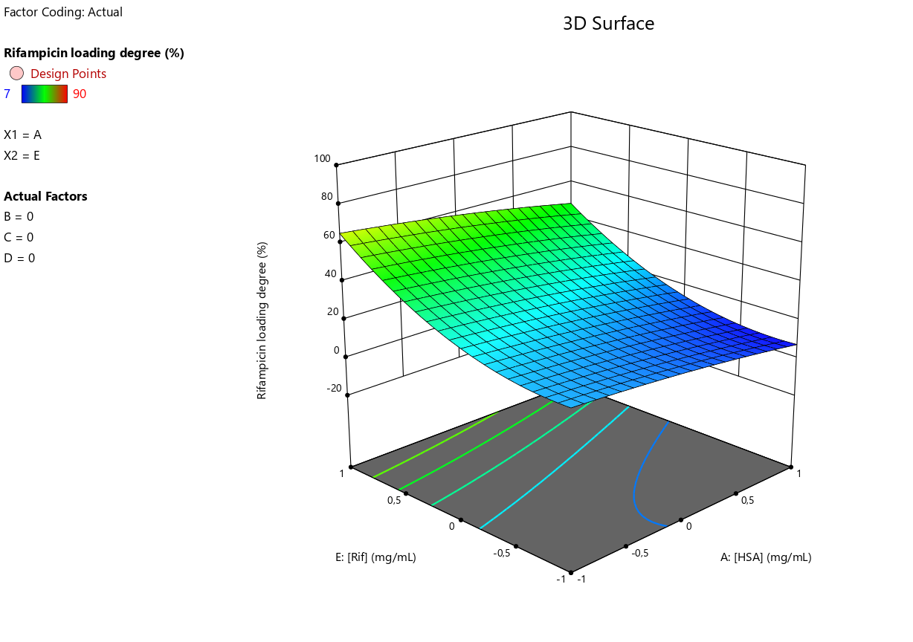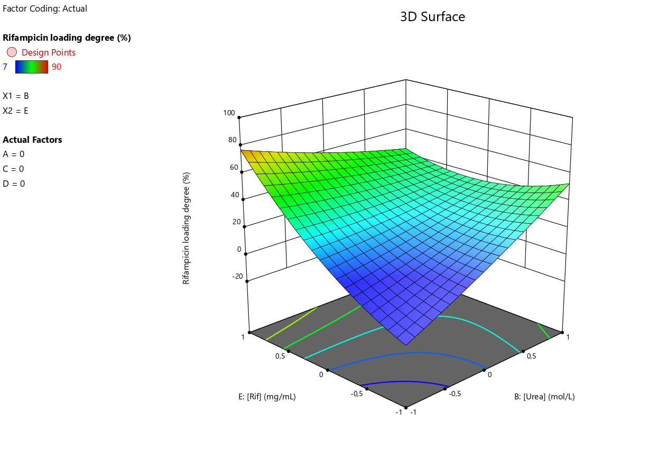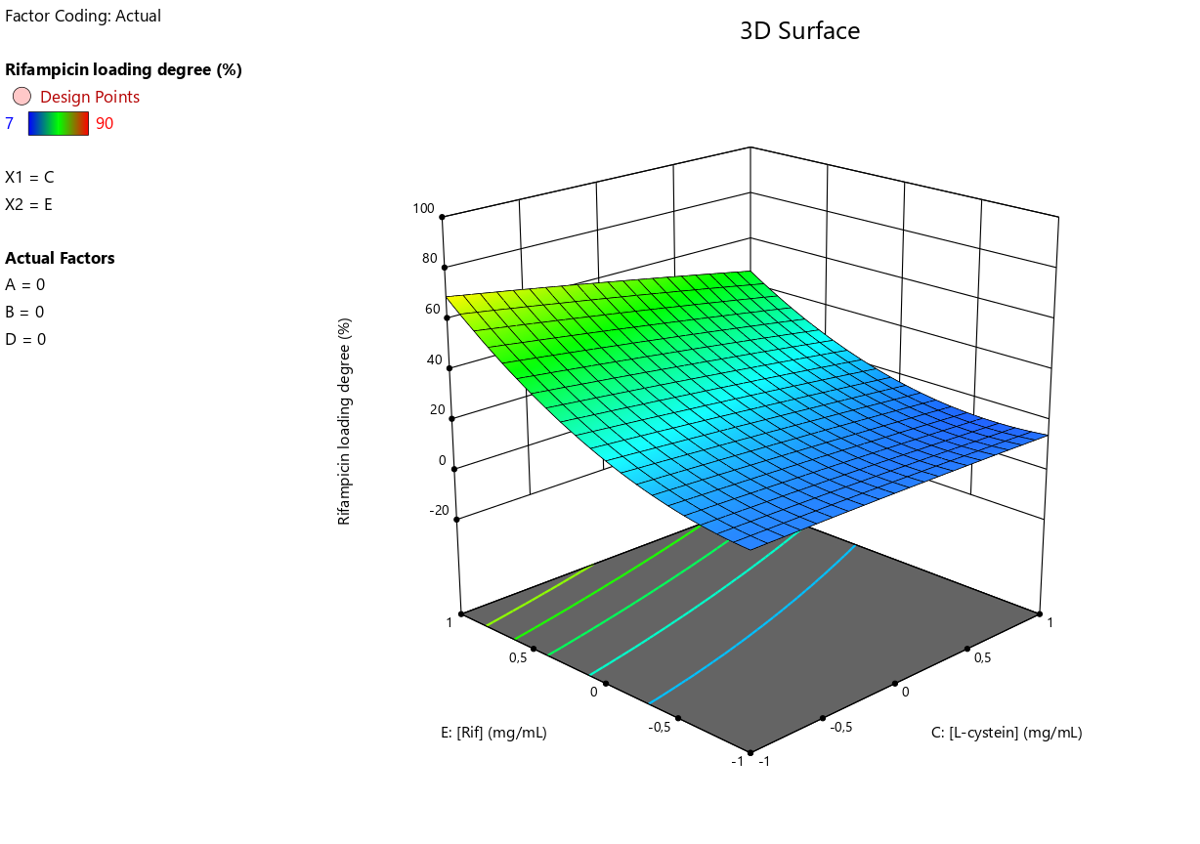

(a) (b) (c)

**Figure 3.** Three-dimensional (3D) response surface plots of the effect of independent factors on the loading degree of rifampicin: (a) [HSA] - [RIF]; (b) [Urea] - [RIF]; (c) [L-cysteine] - [RIF]

Figure 3a and 4a show that drug loading degree decreases with increasing albumin concentration. As the concentration of the drug increases, the loading degree increases, which is consistent. When the highest concentration of urea is used, the NP with the highest drug loading can be obtained (Figure 3b and 4b). The L-cysteine concentration does not significantly affect the loading degree of rifampicin (Figure 3c) and the loading degree of isoniazid increases when the L-cysteine concentration is increased (Figure 4c).

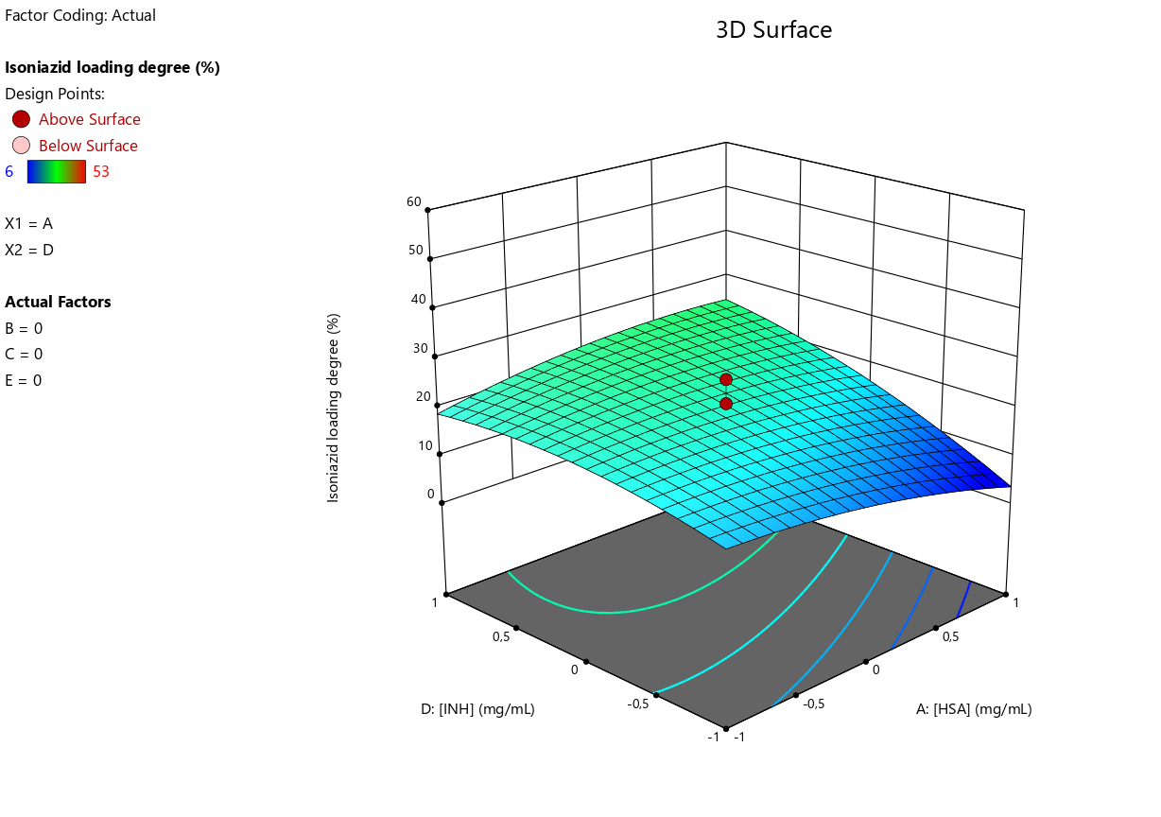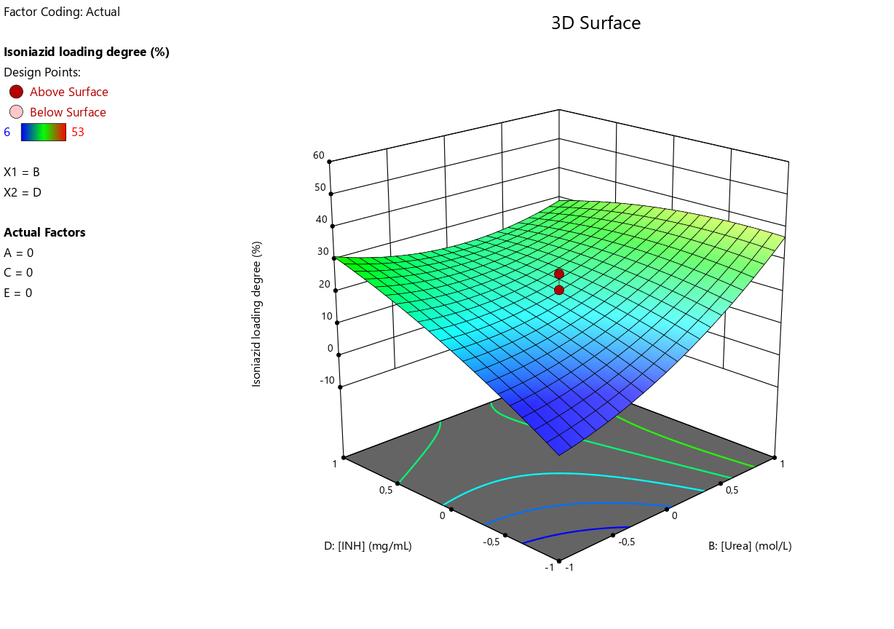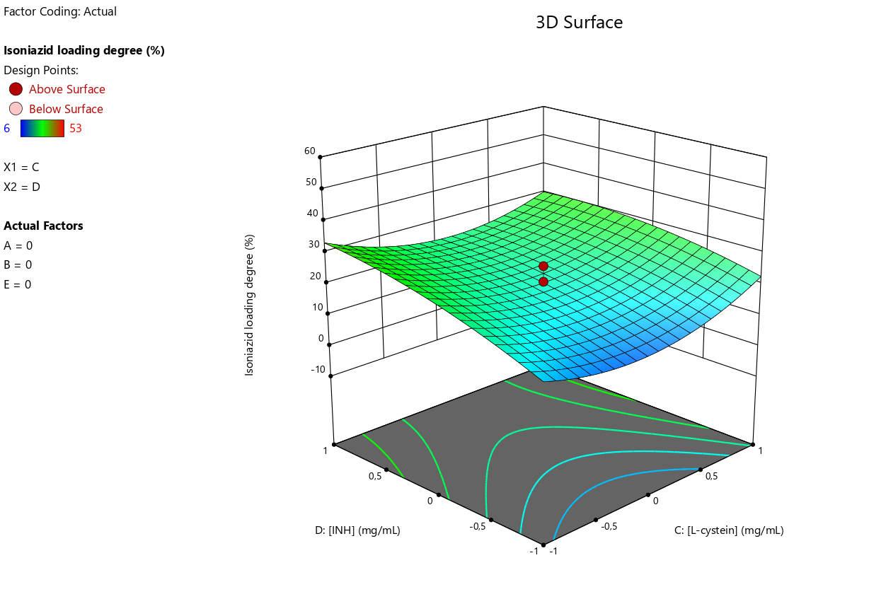

(a) (b) (c)

**Figure 4.** Three-dimensional (3D) response surface plots of the effect of independent factors on isoniazid loading degree: (a) [HSA] - [INH]; (b) [Urea] - [INH]; (c) [L-cysteine] - [INH]

After processing the data by ANOVA, parameters were selected to optimize the process to produce NPs with minimum size and maximum drug loading. The best parameters to obtain HSA-INH-RIF nanoparticles were found to be the following concentrations: HSA – 20 mg/mL, Urea – 3.78 mol/L, L-cysteine – 0.5 mg/mL, isoniazid – 8 mg/mL, rifampicin – 4mg/mL. Experiments were carried out to confirm the predicted optimum parameters from the CCD method. A good agreement between the predicted particle size and the experimental particle size was observed (Table-4). Hence, the size of the synthesized HSA-INH-RIF nanoparticles can be improved by the CCD method.

**Table 4.** Predicted and experimental results for HSA-INH-RIF NPs

|  |  |  |  |  |  |
| --- | --- | --- | --- | --- | --- |
|  | Size (nm) | PdI | Loading degree of rifampicin, % | Loading degree of isoniazid, % | NPs’ yield, % |
| Predicted | 214.2 | 0.246 | 43 | 29 | 44 |
| Experimental | 216.7±3.7 | 0.286±4.9 | 44 | 27 | 45 |
| Error % | 1.2 | 16 | 2.3 | 6.9 | 2.3 |

*3.2. Study of physico-chemical parameters of the HSA-INH-RIF nanoparticles*

The morphology of the produced HSA-INH-RIF nanoparticles was studied by scanning electron microscope (SEM) and the images obtained are shown in Figure 5. The particles have spherical morphology and the average size of nanoparticles calculated by ImageJ software is 188.7±8.8 nm.

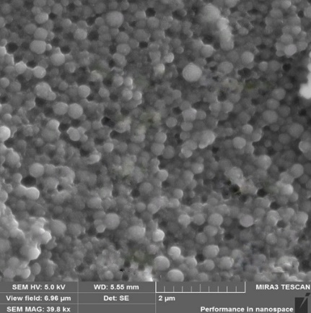

**Figure 5.** SEM image of optimized HSA-INH-RIF nanoparticles

In order to confirm the incorporation of the drugs into the polymer matrix, Differential scanning calorimetry (DSC) and thermogravimetric analysis (TGA) were performed, thermograms of isoniazid, rifampicin, HSA NPs and HSA-INH-RIF NPs are shown in Figure 6.

The main endothermic peak for INH and RIF (pure preparations) was observed at 177.36 and 258.75 ºC respectively (Figure 6). The sharply tapering peak indicates a crystalline form of drugs. A mass loss of up to 68% of isoniazid occurs between 260-450 °C, which may correspond to the decomposition temperature of the drug [30]. The presence of RIF as polymorph I can be explained by the TGA thermogram (Figure 6b). The thermal decomposition process took place in two stages [31]. The first stage occurred rapidly between 231 and 283 °C with a mass loss of about 21.5%, while the second stage occurred more slowly between 292 and 615 °C with a mass loss of 50%. HSA NPs showed a characteristic endothermic peak at around 120 ºC, which probably corresponds to their melting period (Figure 6c). DSC for HSA-INH-RIF NPs showed a slight shift of the endothermic peak towards higher temperatures compared to empty albumin NPs, probably due to the inclusion of drugs in the polymer matrix (Figure 6d).

 

(а) (b)

 

(с) (d)

**Figure 6.** Thermogravimetric analysis and differential scanning calorimetry of the produced albumin nanoparticles and HSA-INH-RIF NPs

The in vitro release of rifampicin and isoniazid from the polymeric albumin matrix was studied by dialysis method (Figure 7).



**Figure 7.** Cumulative release of rifampicin and isoniazid from the polymeric matrix of HSA nanoparticles

HSA-INH NPs produced under optimized conditions were dispersed in phosphate-buffered saline (PBS; pH = 7.4) at 200 rpm and 37 °C. The amount of drug released into the medium was determined at 24-hour intervals by HPLC. A slow and prolonged release of the immobilized drugs was observed. Thus, 4.3 mg/mL rifampicin and 5.2 mg/mL isoniazid were released from the polymeric matrix within 24 hours using a dialysis membrane. The data in Figure 7 show that the release is prolonged, prevents fluctuations in blood concentrations and maintains a constant therapeutic concentration for an extended period of time.

4. Conclusions

Optimization of albumin-based nanoparticles loaded with rifampicin and isoniazid by desolvation is a promising approach to improve the properties of anti-TB drugs. The use of nanoparticles achieves multiple advantages, such as increased stability, controlled size and shape, as well as increased bioavailability and drug activity. The obtained nanoparticles had satisfactory characteristics (mean size 216.7±3.7 nm, polydispersity 0.286±4.9, loading degree of rifampicin 44% and isoniazid 27% and NPs’ yield 45%) and spherical shape. The method of central composite design provides an efficient approach to optimize nanoparticle synthesis. The effect of different factors on particle size, polydispersity index and drug loading degree were analyzed by ANOVA. It was determined that nanoparticles prolong the drug release. Further toxicological and antimycobacterial studies will be carried out to evaluate their safety and efficacy at different stages of clinical trials.

**Author Contributions:** Conceptualization, Y.T.; data curation, Y.T., A.G. and T.Z.; investigation, D.S. and A.D.; resources, A.G.; writing—original draft, A.G.; writing—review and editing, Y.T. and T.Z. All authors have read and agreed to the published version of the manuscript.

**Funding:** This research was funded by the framework of program-targeted funding of the Ministry of Education and Science of the Republic of Kazakhstan, grant number AP14871344 “Development of colloidal drug delivery systems based on biopolymers for tuberculosis chemotherapy”.

**Data Availability Statement:** We encourage all authors of articles published in MDPI journals to share their research data. In this section, please provide details regarding where data supporting reported results can be found, including links to publicly archived datasets analyzed or generated during the study. Where no new data were created, or where data is unavailable due to privacy or ethical restrictions, a statement is still required. Suggested Data Availability Statements are available in section “MDPI Research Data Policies” at https://www.mdpi.com/ethics.

**Conflicts of Interest:** The authors declare no conflict of interest

References

1. Global tuberculosis report 2022. Geneva: World Health Organization; 2022. Licence: CC BY-NC-SA 3.0 IGO.

2. Ge, Z., Ma, R., Xu, G., Chen, Z., Zhang, D., Wang, Q., Hei, L., & Ma, W. (2018). Development and In Vitro Release of Isoniazid and Rifampicin-Loaded Bovine Serum Albumin Nanoparticles. Medical Science Monitor, 24, 473–478. <https://doi.org/10.12659/msm.905581>

3. Sotgiu, G., Centis, R., D’ambrosio, L., & Migliori, G. B. (2015). Tuberculosis Treatment and Drug Regimens. Cold Spring Harbor Perspectives in Medicine, 5(5), a017822–a017822. <https://doi.org/10.1101/cshperspect.a017822>

4. Mazlan, M.K.N.; Mohd Tazizi, M.H.D.; Ahmad, R.; Noh, M.A.A.; Bakhtiar, A.;Wahab, H.A.; Mohd Gazzali, A. Antituberculosis Targeted Drug Delivery as a Potential Future Treatment Approach. Antibiotics 2021, 10, 908. <https://doi.org/10.3390/antibiotics10080908>

5. Jhun, B. W., & Koh, W. J. (2020). Treatment of Isoniazid-Resistant Pulmonary Tuberculosis. Tuberculosis and respiratory diseases, 83(1), 20–30. <https://doi.org/10.4046/trd.2019.0065>

6. Somasundaram, S., Ram, A., & Sankaranarayanan, L. (2014). Isoniazid and Rifampicin as Therapeutic Regimen in the Current Era: A Review. Journal of Tuberculosis Research, 02(01), 40–51. <https://doi.org/10.4236/jtr.2014.21005>

7. Kumar, P. S., Vidya, R., Tabassum, & Jageer, M. (2020). Anti-Tuberculosis Treatment: Induced Hepatotoxicity - A Case Report. EJIFCC, 31(3), 242–247.

8. Yakar, F., Yildiz, N., Yakar, A. et al. Isoniazid- and rifampicin-induced thrombocytopenia. Multidiscip Respir Med 8, 13 (2013). <https://doi.org/10.1186/2049-6958-8-13>

9. Combrink, M., Loots, D. T., & du Preez, I. (2020). Metabolomics describes previously unknown toxicity mechanisms of isoniazid and rifampicin. Toxicology Letters, 322, 104–110. <https://doi.org/10.1016/j.toxlet.2020.01.018>

10. Shin, H. J., Chang, J. S., Kim, M. S., Koh, B. G., Park, H. Y., Kim, T. O., Park, C. K., Oh, I. J., Kim, Y. I., Lim, S. C., Kim, Y. C., Koh, Y. I., & Kwon, Y. S. (2021). Hypersensitivity reactions to multiple anti-tuberculosis drugs. PloS one, 16(2), e0246291. <https://doi.org/10.1371/journal.pone.0246291>

11. Nasiruddin, M., Neyaz, M. K., & Das, S. (2017). Nanotechnology-Based Approach in Tuberculosis Treatment. Tuberculosis research and treatment, 2017, 4920209. <https://doi.org/10.1155/2017/4920209>

12. Nabi, B., Rehman, S., Aggarwal, S., Baboota, S., & Ali, J. (2020). Nano-based anti-tubercular drug delivery: an emerging paradigm for improved therapeutic intervention. Drug delivery and translational research, 10(4), 1111–1121. <https://doi.org/10.1007/s13346-020-00786-5>

13. Borah Slater, K.; Kim, D.; Chand, P.; Xu, Y.; Shaikh, H.; Undale, V. A Current Perspective on the Potential of Nanomedicine for Anti-Tuberculosis Therapy. Trop. Med. Infect. Dis. 2023, 8, 100. <https://doi.org/10.3390/tropicalmed8020100>

14. Baranyai, Z., Soria‐Carrera, H., Alleva, M., Millán‐Placer, A. C., Lucía, A., Martín‐Rapún, R., Aínsa, J. A., & la Fuente, J. M. (2020). Nanotechnology‐Based Targeted Drug Delivery: An Emerging Tool to Overcome Tuberculosis. Advanced Therapeutics, 4(1), 2000113. Portico. <https://doi.org/10.1002/adtp.202000113>

15. Donnellan, S., & Giardiello, M. (2019). Nanomedicines towards targeting intracellular Mtb for the treatment of tuberculosis. Journal of Interdisciplinary Nanomedicine, 4(3), 76–85. Portico. <https://doi.org/10.1002/jin2.61>

16. Galiyeva, A.R., Tazhbayev, Ye.M., Zhumagaliyeva, T.S., & Daribay, A.Т. (2022) Encapsulation of Isoniazid in Polylactide-Co-Glycolide Nanoparticles by Nanoprecipitation. Bulletin of the University of Karaganda – Chemistry, 107(3), 208-217. <https://doi.org/10.31489/2022Ch3/3-22-17>

17. Tazhbayev, Ye. M., Galiyeva, A. R., Zhumagaliyeva, T. S., Burkeyev, M. Zh., Kazhmuratova, A. T., Zhakupbekova, E. Zh., Zhaparova, L. Zh., & Bakibayev, A. A. (2021). Synthesis and characterization of isoniazid immobilized polylactide-co-glycolide nanoparticles. Bulletin of the Karaganda University. “Chemistry” Series, 101(1), 61–70. <https://doi.org/10.31489/2021ch1/61-70>

18. Tazhbayev, Y., Galiyeva, A., Zhumagaliyeva, T., Burkeyev, M., & Karimova, B. (2021). Isoniazid-Loaded Albumin Nanoparticles: Taguchi Optimization Method. Polymers, 13(21), Article 3808. <https://doi.org/10.3390/polym13213808>

19. Hassanin, I., & Elzoghby, A. (2020). Albumin-based nanoparticles: a promising strategy to overcome cancer drug resistance. Cancer drug resistance (Alhambra, Calif.), 3(4), 930–946. <https://doi.org/10.20517/cdr.2020.68>

20. Esim, O., & Hascicek, C. (2021). Albumin-based Nanoparticles as Promising Drug Delivery Systems for Cancer Treatment. Current Pharmaceutical Analysis, 17(3), 346–359. <https://doi.org/10.2174/1573412916999200421142008>

21. Patel, A., Redinger, N., Richter, A., Woods, A., Neumann, P. R., Keegan, G., Childerhouse, N., Imming, P., Schaible, U. E., Forbes, B., & Dailey, L. A. (2020). In vitro and in vivo antitubercular activity of benzothiazinone-loaded human serum albumin nanocarriers designed for inhalation. Journal of Controlled Release, 328, 339–349. <https://doi.org/10.1016/j.jconrel.2020.08.022>

22. Weber. C., Coester. C., Kreuter. J., & Langer. K. (2000). Desolvation process and surface characterisation of protein nanoparticles. International Journal of Pharmaceutics. 194(1). 91–102. <https://doi.org/10.1016/s0378-5173(99)00370-1>

23. Elzoghby. A. O., Samy. W. M., & Elgindy. N. A. (2012). Albumin-based nanoparticles as potential controlled release drug delivery systems. Journal of Controlled Release. 157(2). 168–182. <https://doi.org/10.1016/j.jconrel.2011.07.031>

24. Tazhbayev Ye.M., Burkeyev M.Zh., Zhaparova L.Zh., Zhumagaliyeva T.S. & Agdarbek A.A. (2019). Albumin nanoparticles loaded with the antitumor drug «Hydroxycarbamide» by the incorporation method. Bulletin of the Karaganda University. “Chemistry” Series. 93(1). 48–53. <https://doi.org/10.31489/2019ch1/48-53>

25. Von Storp. B., Engel. A., Boeker. A., Ploeger. M., & Langer. K. (2012). Albumin nanoparticles with predictable size by desolvation procedure. Journal of Microencapsulation. 29(2). 138–146. <https://doi.org/10.3109/02652048.2011.635218>

26. Langer. K., Balthasar. S., Vogel. V., Dinauer. N., von Briesen. H., & Schubert. D. (2003). Optimization of the preparation process for human serum albumin (HSA) nanoparticles. International Journal of Pharmaceutics. 257(1-2). 169–180. <https://doi.org/10.1016/s0378-5173(03)00134-0>

27. Tazhbayev Ye.M., Burkeyev M.Zh., Zhaparova L.Zh., Zhumagaliyeva T.S., & Arystanova Zh.T. (2018). Preparation and characterization of empty nanoparticles of poly-D.L-lactic acid and serum albumin. Bulletin of the Karaganda University. “Chemistry” Series. 90(2). 40-44.

28. Tazhbayev, Y., Mukashev, O., Burkeev, M., Kreuter, J. Hydroxyurea-Loaded Albumin Nanoparticles: Preparation, Characterization, and In Vitro Studies. Pharmaceutics 2019, 11, 410. <https://doi.org/10.3390/pharmaceutics11080410>.

29. Tazhbayev, Y., Mukashev, O., Burkeyev, M., Lozinsky, V.I. Synthesis and Comparative Study of Nanoparticles Derived from Bovine and Human Serum Albumins. Polymers 2020, 12, 1301. <https://doi.org/10.3390/polym12061301>.

30. Galiyeva, A.R., Tazhbayev, Ye.M., Zhumagaliyeva, T.S., Sadyrbekov, D.T., Kaikenov, D.A., Karimova, B.N., & Shokenova, S.S. (2022) Polylactide-co-glycolide nanoparticles immobilized with isoniazid: Optimization using the experimental Taguchi method. Bulletin of the University of Karaganda – Chemistry, 105(1), 69-77. <https://doi.org/10.31489/2022Ch1/69-77>

31. Alves, R., Reis, T. V. da S., Silva, L. C. C. da, Storpírtis, S., Mercuri, L. P., & Matos, J. do R. (2010). Thermal behavior and decomposition kinetics of rifampicin polymorphs under isothermal and non-isothermal conditions. Brazilian Journal of Pharmaceutical Sciences, 46(2), 343–351. <https://doi.org/10.1590/s1984-82502010000200022>

**Disclaimer/Publisher’s Note:** The statements, opinions and data contained in all publications are solely those of the individual author(s) and contributor(s) and not of MDPI and/or the editor(s). MDPI and/or the editor(s) disclaim responsibility for any injury to people or property resulting from any ideas, methods, instructions or products referred to in the content.